KEY SITES FOR PROTECTING NAURU’S BIODIVERSITY
Source: Rapid Biodiversity Assessment (BioRAP) Nauru, June 2013, Synthesis Report, Key Findings and Recommendations

Priority sites for protection and management should be those showing the least disturbance, the highest species richness, the greatest numbers of rare or endangered species, and the most value as wildlife habitat. Particular emphasis is placed on sites and species that are important as a food source
including fish and other marine species, and noddy rookeries. Special consideration should also be given to those areas containing culturally important and useful plants such as coconut and pandanus groves, the remaining coastal strand and escarpment forest, and mangroves. It is also important that local communities (resource users and owners) are involved in the planning, implementation, monitoring, planting and maintenance of these areas. While many areas on and around Nauru retain
indigenous natural values, a total of eight areas and a scatter of near extinct coastal trees are being recommended as priorities for conservation action (see map). These include five terrestrial areas (Proposed Conservation Areas – PCAs) and three marine areas (Proposed Marine Management Areas – PMMAs). Local knowledge, historical reports and the findings from this BIORAP, underpin the recommendations for key conservation and management areas. The proposed areas are:
- possibly the minimum that is required to sustain very ancient but presently depleted and declining marine and terrestrial ecosystems;
- intended to complement each other;
- intended to be inclusive of originally representative species patterns and habitats
that define Nauru as distinct from other island ecosystems;
- designed to integrate habitat sequences and to be able to sustain coral, plant or animal populations within their boundaries.

They also:
- recognise that many birds, fishes and marine species travel vast distances and depend on these areas. This is a defining ecosystem feature for Nauru; have multiple use areas and are sometimes where people may live or use them regularly. This will continue but with the insight that these areas have a special character and set of resources that are currently threatened and need to be sustained for future generations.

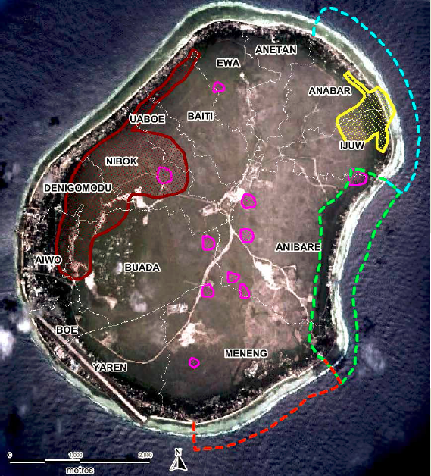
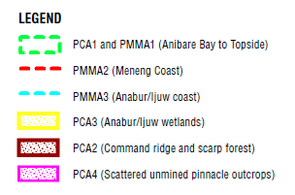

Figure 2. Priority terrestrial and marine sites for conservation.

