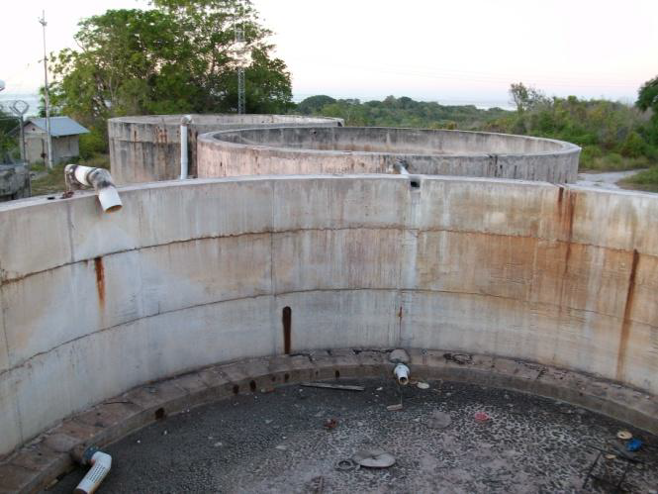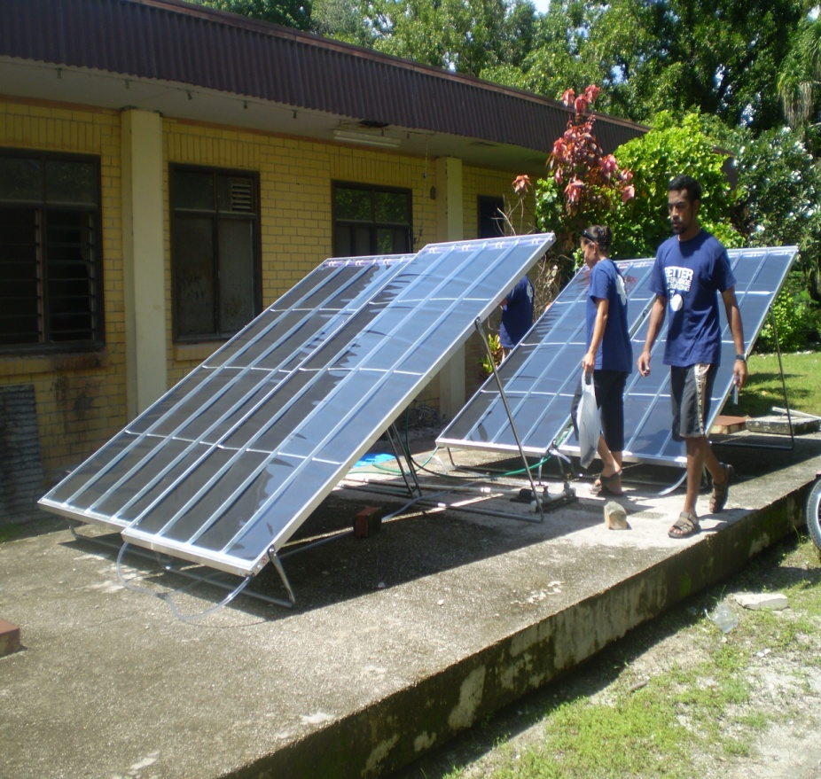

**Enhance resilience to drought in Nauru**

**Guidelines for the design of conjunctive water supply systems in Nauru**



**Pacific Adaptation to**

**Climate Change (PACC)**

**-**

**Nauru Demonstration Project**

**Final Draft**



|  |
| --- |
| Foreword |

The *guidelines for the design of conjunctive water supply systems to improve resilience to drought in Nauru* have been developed as part of the Pacific Adaptation to Climate Change (PACC) demonstration project initiative. The PACC project involves 14 pacific countries and is aimed at building resilience to impacts of climate change in the key vulnerable socio-economic sectors. In Nauru, drought has been identified has one of the most threatening impact that could result from change in climate patterns. In order to improve the country’s resilience to drought events, the PACC project is currently addressing water use and water resource management.

These guidelines are mainly directed at government agencies, local NGOs, regional organisations and donor agencies interested in developing conjunctive water supply systems in the Pacific Island countries, in order to improve the availability of drinking water, especially during drought periods. It details the process undertook by the PACC team to design two demonstration projects:

1. The rehabilitation of the seawater network in location area
2. The implementation of solar water purifiers in selected Households in Aiwo district

The demonstration projects principally aims at supporting effective planning. The process engaged is to identify suitable adaptation measures and to put them into action in order to evaluate their effectiveness in addressing identified issues that results from drought events, at a community level. In detailing the steps involved to design and implement the two projects, this document aims to provide the reader with the following information:

* An understanding of the challenges that come with drought events in Nauru and added stress brought by climate change
* Demonstrate how conjunctive water supply systems are a sensible and sustainable way to improve resilience to drought events in Nauru
* Details necessary steps to design and implement a water supply project in the Nauru context
* From the PACC team experience, state the critical factors that need to be addressed in order for Nauru to implement effective adaptation measures

For more information on the Demonstration projects and the PACC project in Nauru, please contact the Project coordinator (contact details bellow).

**Author:** Louis Bouchet, Consultant PACC project, Nauru

**Email:** [lpm.bouchet@gmail.com](mailto:lpm.bouchet@gmail.com)

**Contributors:** Mavis Depaune, PACC project Coordinator, Nauru

**Email:** [mavis.depaune@naurugov.nr](mailto:mavis.depaune@naurugov.nr)

Natasha Detanamo, PACC project assistant, Nauru

**Email:** [Natasha.detanamo@naurugov.nr](mailto:Natasha.detanamo@naurugov.nr%20)

Table of Contents

Foreword 2

Introduction: The PACC Project in Nauru 4

1.Climate change in the Nauru context 4

1.1. Brief history of climate change policy in Nauru 4

1.2. Identified impacts of climate change 4

2.PACC and the national climate change adaptation strategy 4

1.3. Current projects and initiatives for the Climate Change sector 4

2.3. PACC objectives 5

Part I: Country background information and context analysis 6

1.Description 6

2.Socio-economic background 6

3.Climate variability and climate change 7

1.1. Nauru’s climate: High variability 7

1.2. Vulnerability to drought 8

1.3. Climate change and future projections 8

1.4. Projections and interpretation 9

4.The water sector 9

1.1 Water resources 9

4.2. Water supply 10

4.3. Water uses, consumption and demand 11

4.4. Water management and institutional capacity 13

4.5. Summary of key issues faced by the sector and emerging threats 14

5.Conjunctive use of water in Nauru 15

5.1 Conjunctive use of water, what is it? 15

5.2 Conjunctive water use in Nauru 16

Part II: PACC demonstration projects 18

1.Introduction 18

2.Selected sites 18

2.1. Sites location 18

2.2. Selection criteria 19

3.Vulnerability and adaptation assessment 19

3.1. Objectives and methodology 19

3.2. Vulnerability assessment: Key findings 21

3.3. Selection of adaptation measures 23

4.Demonstration projects overview 27

4.1. Project 1: Solar Purifiers for selected Households in Aiwo district 27

4.2. Project 2: Seawater reticulation system for toilet flushing in *Location* 29

5.Expected outcomes 33

6.Monitoring and Evaluation 34

6.1. Indicators and monitoring process 34

6.2. Evaluation process 35

Recommendations 36

References 37

|  |
| --- |
| Introduction: The PACC Project in Nauru |

## Climate change in the Nauru context

### Brief history of climate change policy in Nauru

The potential disastrous effects of climate change on atoll islands have been recognized for more than 30 years. In 1985, Nauru was recorded the first signatory to the climate change convention in Vienna. In 1994, Nauru has been with the first set of country to join the United Nation Framework Convention on Climate Change (UNFCC). In this same year, Nauru participated with the Alliance of Small Island States (AOSIS), in putting forward the first draft text in the Kyoto protocol (UNFCC 1999).

Various projects have since been implemented in Nauru. The first National communication, prepared under the UNFCC in 1999 was one the first document to review Nauru’s vulnerability to climate change and identify gaps and critical sectors affected. The Second National Communication (SNC) project under the UNFCC started in 2008, leading to the creation of the National Adaptation Plan of Action (NAPA), currently under review by parliament cabinet (i.e. as in February 2012). Along with the NAPA, a climate change unit has been created with primary mission of drafting the first National climate change policy for Nauru.

### Identified impacts of climate change

According to the NAPA (2011), the following impacts have been identified as primary effect of climate change on the Nauru:

1. Coastal erosion - loss of land

2. Flooding– kitchen gardens, food crops and schools affected

3. Low productivity/yield of crops

4. Frequent/continuous intense rainfall and sea storms (storminess)

5. Drought affecting water supply and increasing risk of fires

6. Sea-level rise – inundation of land and saltwater intrusion

7. Loss of natural ecosystem resources – mangroves and littoral vegetation, coral reefs

In Nauru, climate change effects are likely to firstly affect the water sector. Nauru, due to its location near the equator is not likely to experience Cyclones or other natural disaster but drought and heavy rain events. Drought is already an important threat an extended drought periods could become more extreme in the future. Sea-level rise could become an issue in increasing saltwater intrusion and lifting up groundwater level, increasing the risk of contamination from surface activities.

## PACC and the national climate change adaptation strategy

### Current projects and initiatives for the Climate Change sector

With the termination of the SNC project in 2011 and the creation of the climate change unit, PACC is currently the sole AID program directly targeting climate change in Nauru. Under the Environment division of the commerce, industry and environment (CIE), the climate change unit aims at reducing impact of climate change in Nauru through a series of measure and the implementation of a climate change policy framework (i.e. under development). The unit is also addressing coastal erosion, an activity previously under the former SNC project (Figure 1).

Under the project division, the NBSAP project is currently reviewing the challenges related to stress on natural ecosystems. The Integrated Water Resource Management (IWRM) project is working closely with PACC on water related issues, more particularly sanitation and water use efficiency. As a combined effort from both PACC and IWRM projects, the water unit (i.e. to be implemented current 2012) will be overarching the water sector and in charge of implementing the water policy (i.e. endorsed in January 2012).

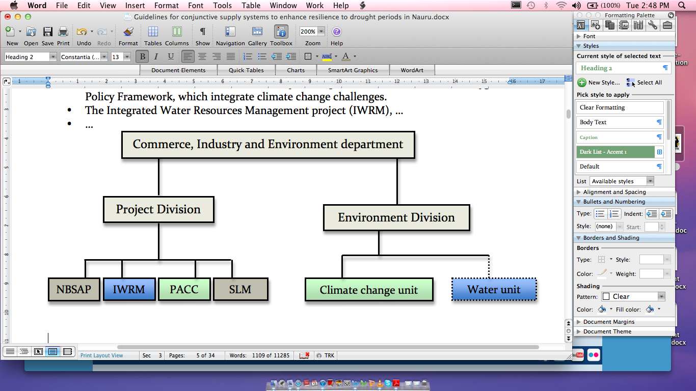

Figure 1: Organizational structure of the climate change sector

To be mentioned, the Grass root program is installing solar groundwater pump and storage tanks at a district level and JICA, in collaboration with CIE, is implementing a new solar Reverse Osmosis (Desalination) plant in 2012.

### PACC objectives

In collaboration with the Republic of Nauru (RoN) government, The PACC project has identified the water sector as the most vulnerable to Climate Change and proposed to focus on adaptation measures to mitigate impact of climate change on water resources and supply. The Project objective is: *Demonstrating the benefits of taking climate change into consideration in the water sector to better prepare for future climate change risks.*

In Nauru and especially for the water sector, the approach to climate change is a *no-regret* approach, considering that climate change is likely to exacerbate current threats (i.e. drought, salt-water intrusion, groundwater contamination). Three main outcomes are expected from the project as follows:

* **Outcome 1:** Policy changes to deliver immediate vulnerability-reduction benefits in context of emerging climate risks defined in Nauru.
* **Outcome 2:** Demonstration measures to reduce vulnerability in water sector implemented.
* **Outcome 3:** Capacity to plan for and respond to changes in climate-related risks improved.

The present document is detailing the design process for the implementation of the demonstration measures (outcome 2).

|  |
| --- |
| Part I: Country background information and context analysis |

## Description

Nauru is a small isolated raised coral limestone island located 1243 km north east of the Solomon Islands and 60 kilometers south of the equator. The island area is 22 square kilometers (2,200 hectares) (NPC 1988). Most of the population is living in the 150-300m wide circling coastal plain, and the Buada lagon area. The “Topside” rises to 61m and is composed of a dolomitic limestone which was covered by large deposits of high grade tricalcium diphosphate, now largely mined out (Picture 1). The mined out land exposes a karrenfeld of karst pinnacles (Jacobson and Hill 1997).

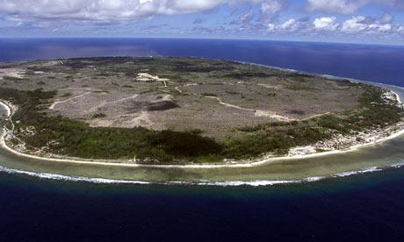

Picture 1: Coastal plain and Topside mined out land

## Socio-economic background

Nauru is the smallest island nation, with a population of 10 185. The official language is Nauruan, spoken among 7000 people. However English is widely spoken and understood. The average Household is composed of 6 persons with an average yearly income of $9.555 per Household (SPC 2011).

Economic development is very limited with Phosphate exportation being the main source of income. Being extensively mined during the past 50 years, remaining phosphate resources are scarce and mining activity has significantly reduced. Serious issues such as rehabilitation of mined land and replacement of incomes from mining activities threaten Nauru’s future. In the late 1990s, the government faced virtual bankruptcy from mismanagement of its trust funds, developed to sustain Nauru’s future in anticipation of the exhaustion of phosphate resources.

The state is heavily indebted and Nauru’s economy relies on foreign development grants (ADB 2010).

With no major industries and services, employment opportunities are rare and principally through the public services and state owned enterprises (ADB 2010). The closure of the Australian Offshore Processing Center (OPC) for asylum seekers left hundreds of locals without employment. Its eventual reopening could give Nauru a temporary alternative to generate more income. The current unemployment rate is 22.7% (PRISM 2010). Deterioration of housing, the hospital and other capital plants and infrastructure is a significant concern (CIA 2009), including access to water and adequate sanitation.

Public services such as education, transport and health care (Nauruan citizen only) are free and there is a strong perception among Nauruans that the government should be in charge of running costs and maintenance of numerous facilities, including water supply and sanitation. This comes from the time of economic prosperity, when a broad range of public services was provided to the community (e.g. maintenance of housing by Public works). Belief that past governments should be accountable for mismanagement of phosphate incomes that lead to the bankruptcy also contributes to this perception (Audoa and Tilling 2010).

## Climate variability and climate change

### Nauru’s climate: High variability

Nauru’s climate is equatorial, hot and humid throughout the year, with mean daily temperatures ranging from 24°C to 31°C and a mean annual rainfall of 2,117mm. The “wet” season extends from December to April where more than 200mm of rain per month is common (Figure 2).

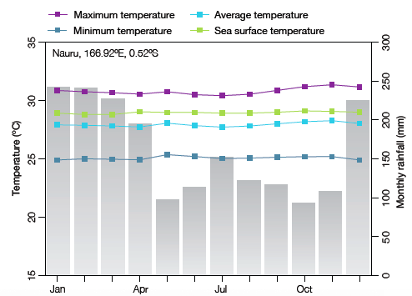

Figure 2: Seasonal rainfall and temperature in Nauru

According to the rainfall record available from 1984 (with some few gaps), Nauru’s rainfall is characterized with a high degree of variability, with a minimum annual rainfall of 278mm recorded in 1950 and a maximum of 4,588mm in 1930.

Nauru’s high climate variability is mainly attributed to El Niño Southern Oscillation (ENSO) events. Rainfall patterns are strongly related to ENSO events in Nauru (Figure 3): An irregular warming in Sea Surface Temperatures (SST) -El Niño event- results in higher rainfall whilst an irregular cooling in SST -La Niña event- result in reduced rainfall and likelihood of an extended drought period (White 2011).



Figure 3: The strong correlation between annual rainfall in Nauru and the sea surface temperature anomaly in the Niño 3.4 region. Source: White 2011

### Vulnerability to drought

Drought periods are a frequent threat for the country. Occurring on average every 5 years, they can last up to 3 years (table 1). The country is particularly vulnerable to extended drought periods as it relies primarily on rainwater for its water supply.

Table 1: Characteristic of major 6 months drought

|  |  |  |  |  |  |  |
| --- | --- | --- | --- | --- | --- | --- |
| **No.** | **Start Date** | **End Date** | **Duration (months)** | **Lowest Ranking (%)** | **Drought Interval (years)** | **6 months Rainfall (mm)** |
| 1 | Sep-49 | Apr-51 | 19 | 1.8 | - | 65 |
| 2 | Jul-54 | Feb-57 | 31 | 8.2 | 4.8 | 171 |
| 3 | Jul-64 | Jan-65 | 6 | 5 | 10.0 | 130 |
| 4 | Sep-70 | Feb-72 | 17 | 0.9 | 6.2 | 49 |
| 5 | Jul-73 | Jan-75 | 18 | 0.1 | 2.9 | 31 |
| 6 | Aug-75 | Mar-76 | 7 | 7.8 | 2.0 | 158 |
| 7 | Aug-78 | Feb-79 | 6 | 7.4 | 3.0 | 155 |
| 8 | Dec-83 | Mar-86 | 27 | 5.8 | 5.3 | 136 |
| 9 | Jun-88 | Jan-90 | 19 | 0.0 | 4.5 | 23 |
| 10 | Aug-95 | Mar-97 | 19 | 2.5 | 7.2 | 89 |
| 11 | May-98 | Aug-01 | 39 | 0.3 | 2.7 | 36 |
| 12 | Jun-07 | Aug-09 | 26 | 0.2 | 9.1 | 34.8 |
| 13 | Sept-10 | Jul-11 | 10 | 2 | 2.2 | 70.5 |
|  |  | **Mean** | **18.8** |  | **4.6** | **89.8** |

**(Updated from White 2011)**

### Climate change and future projections

Unlike climate variability, climate change refers to modification in the climate pattern on a longer time scale. Climate change is often attributed to the human activity and emission of Co2 coming from Fossil Fuel combustion and responsible for what is called ‘global warming’. Most known effects of global warming are sea level rise and increase of extreme climate events.

There is yet no evidence that global warming is impacting on ENSO events, however some studies suggest that the it could be a major factor in accentuating the current climate regimes and the changes from normal that come with ENSO events (PACC 2009).

According to the last climate change projections for Nauru (PCCSP 2011):

* Rainfall is expected to increase during the course of the century (High confidence);
* Projections indicate an increase in rainfall of 5% by 2030 and 15% by 2090 (Low confidence);
* Incidences of drought periods are expected to decrease over the course of the century (Moderate confidence);
* Sea level rise is expected to increase (High confidence);
* Projections indicate a sea level increase of 15 to 20 cm by 2030 (moderate confidence);

### Projections and interpretation

Incorporating climate change science into sector planning and policymaking is challenging because of the uncertainty involved. As for Nauru, climate change scenarios have seen some evolution since the beginning of the PACC project: During the design phase of the project in 2009, climate change projections indicated the likelihood of an increase in extreme events (long lasting drought and high rainfall events). The latest projection doesn’t reject this scenario but detail that drought could become less frequent.

Because drought will inevitably remain a threat for Nauru (regardless if events occur every 7 years instead of 5), the approach taken by Nauru (i.e. NAPA, PACC) is a no regret approach: Improvements in the water sector are needed and will be beneficial for Nauru, regardless of climate change.

However climate change scenarios have led us in the need to urgently increase the country’s adaptation capacity to drought event and heavy rainfall and to monitor and progressively address issues related to sea level rise.

## The water sector

### Water resources

Water supply sourcesare limited in Nauru and represent a major challenge for water management. There are 3 natural sources of water on the island:

* Rainwater
* Groundwater
* Seawater

However, rainwater is the sole source of freshwater, with the exception of a small area around Ewa district, where groundwater seems to remain fresh. Everywhere else on the island, groundwater is extremely vulnerable to rainfall patterns, with huge variation in salinity levels, from less than 1000us/l (WHO drinking standards) during average and above rainfall years to more than 12000us/l (very brackish water) during drought periods. High salinity is not the only factor that limit the use of groundwater: High rate of contamination with fecal bacteria in domestic wells around the island has been recorded in 2010 in a survey undertaken by SOPAC, which pose serious heath concern associated to the use of groundwater for drinking, but also for cooking, personal bathing and laundry.

Reliance on desalinated seawater is therefore relatively high, especially during drought periods, when the rainfall is insufficient to meet people’s water needs. It is noticeable that seawater remains an important resource of water for Nauruans, especially for bathing during drought periods (Bouchet and Sinclair 2010, CIE 2011).

### Water supply

Considering the lack of freshwater sources on the island, water supply is often divided in two components: The potable water supply and the non-potable water supply:

#### Potable water supply

The potable water supply is limited to domestic rainwater harvesting infrastructure and the desalinated seawater –Reverse Osmosis process- produced at Nauru Utilities Corporation (NUC) and delivered to Households by truck (i.e. excluding bottled water and few freshwater wells).

**Rainwater:** According to a survey undertaken by SOPAC in 2008, the total capacity of domestic rainwater tanks was of about 25.000 Kl, covering 90% of the population, which correspond to approximately 25 days of storage. There is no clear figure on average rainwater capture per household as roofs, gutter and tanks varies in size and working conditions. According to CIE (2011), 50% of the domestic infrastructure is not properly maintained. It is noticeable that the average rainwater tank size is 6000L (BoS 2011), which will be significantly small for the average household of 6 peoples. The SOPAC 2008 survey findings are similar but details the actual average tank capacity per person per house at 3000L, which is more reasonable, offering a month of supply for an estimated consumption of 100L per day (CIE 2011).

**Desalinated seawater:** Reverse osmosis can be produced at a rate of up to 360 KL/day at utilities –The production rate will increase to up to 460KL/day by 2013 (Additional Solar RO plant provided by JICA)-. Current storage capacity at NUA is estimated around 6.000Kl. This figure could go up to 28.000Kl if all the storage tanks were in good condition. However significant loss up to 40% are estimated on these storages. According to the NISIP, repairing leaks in NUA tank farm would bring the storage capacity of the island to up to 35 days of supply. Two other RO plants are in use at Menen hotel and hospital. The Taiwan agriculture farm also has its own small RO unit, similar to Capelle&Partner business.

There is no operational water network in Nauru (i.e. except a small network from the desalination plant to the hospital) and the RO water is delivered by truck. The daily delivery capacity is currently inferior to 300KL/day. However, trucks are frequently hired from other government entities to supplement the capacity when the demand is high.

#### Non-potable water supply

**Groundwater:** The non-potable water supply consists of private wells all around the island and is more complicated to assess, as there is no monitoring program in place. According to Bouchet and Sinclair (2010), there are approximately 350 domestic wells around the island coastal strip with an average total (i.e. entire island) abstraction in April 2010 estimated at 300Kl/day. However, considering that April 2010 was a relatively good rainfall period, it is assumed that during drought periods, abstraction would be significantly higher than that (i.e. lack of rainwater and therefore heavier reliance on groundwater).

**Seawater:** Seawater has always been used has a non-potable water supply source for Nauruan. A seawater reticulation system was once in use in location district, supplying the area with water for toilet flushing and swimming pools. Nowadays, the system has been left to degradation and is not operational anymore. The PACC project is considering rehabilitating the network as part of a conjunctive water resource management initiative (Please refer to page xx. for more details).

### Water uses, consumption and demand

#### Water uses and consumption

Water Usesare mainly domestic. Except from mining activities, there are no major industries on the island. As mentioned previously, rainwater and desalinated water are mainly used for potable purposes. This includes drinking, cooking and to some extent personal bathing and laundry. Groundwater is mainly used for non-potable purpose, which include outdoor uses personal bathing, laundry, and to some extent cooking (NBS 2009, Bouchet and Sinclair 2010).

There is currently no monitoring of water consumption. To be mentioned, few data is available from NUC (i.e. from 200x to 200x with gaps) on the monthly production and delivery of desalinated water.

However, it is acknowledged that water uses and consumption first depend on the availability of rainwater (i.e. rainfall) and secondly, access to the resources. During periods of heavy rainfall, when tanks are full, rainwater is used for both potable and non-potable uses (i.e. including toilet flushing) (Falkland 2009). During average to low rainfall pattern, households are likely to rely on desalinated water in order to maintain their water level (buffer capacity). In this case, households will ration their water for potable use only. This being said, it is also dependent on household access to another source of water for non-potable use (i.e. mainly groundwater). Generally, households with a direct and convenient (i.e. pump and reticulated network) access to groundwater tend to use groundwater for most of their needs (83% of water use) except drinking and cooking (Bouchet and Sinclair 2010).

During extended drought periods, with no more rainwater available, the only source of potable water remaining is desalinated water. With a current supply covering less than a third of the demand, HH become very cautious of their water use, consumption decrease and in most cases, desalinated water is strictly used for drinking purposes. HH with no direct access to groundwater fill buckets and reservoirs from community tanks or neighbors to provide them with non-potable uses.

#### Water demand

There is often confusion between water demand and water consumption. For this document, we will refer to water demand as the amount of water that dwellings would like to access.

In this case, water demand refers to the perception of the community on how much water they would need to sustain their lifestyle, health and livelihood. There is yet to be a water demand-monitoring program in Nauru. It has been recently recognize by the Water, Sanitation and Hygiene Policy and could be implemented in the coming years. In the absence of local data, Nauru’s government recognize water demand estimate (Table 2) as describe in a water plan drafted by Ian Wallis (2001):

Table 2: Water demand for potable and non-potable uses

|  |  |  |
| --- | --- | --- |
| **Water demand** | **Potable** | **Non Potable** |
| **Per person/day** | 100L | 70L |
| **Commercial and others/day** | 270KL – 350KL | 150KL |
| **Total 2011/day** | **1290KL** | **875KL** |
| **Total 2020/day** | 1467KL | 1000KL |

It is acknowledged that theses demand figures are likely to be high for Nauru. Moreover, considering that the current capacity of the desalination plant (360Kl/day) against the actual estimated demand for 2011 (1290Kl) is nearly four times lower, it can seem unrealistic.

However, it is important to bear in mind that domestic rainwater harvesting systems plays an important role in meeting the water demand for potable water. Therefore, stating that Nauru’s current water supply capacity is nearly four times lower than the demand is not correct. A more correct statement is that during drought periods, the island capacity to meet demand for potable water is very low.

#### Drivers for current water consumption

Current water consumption is indubitably linked to the access and availability of water. As detailed before, a dwelling’s consumption will mainly depend on the following criteria:

1. **Current rainfall:** As the majority of the population relies on rainwater as a primary source of potable water, the availability of rain is the main factor that influences water consumption in Nauru. The less the rainfall the more dwellings will require to be supplied with desalinated water. Because the supply of desalinated water is nearly four times lower than the total demand for potable water, the water consumption will decrease.
2. **Rainwater harvesting capacity:** The roof surface, guttering and the tank storage of the dwelling will also have a significant impact on the consumption. The daily consumption per capita for a household of 3 people with sufficient roof and guttering, with a 10.oool tank will most likely be higher than the same household with 10 people living in.
3. **Access to a secondary water source for non-potable uses:** At similar rainwater harvesting capacity, a dwelling with access to a secondary source of water (i.e. non potable source such as groundwater or seawater) will logically consume more water than a dwelling without access to such facilities.
4. **Income:** Often seen as a less important factor, income can impact on water consumption. Households who can afford regular supply of desalinated water are likely to use more water than others. However the current capacity of desalinated water supply is too low to allow a regular supply to households during drought periods (i.e. waiting list). Income can also play a role in households’ ability to expend/improve their rainwater harvesting capacity or groundwater access.

Therefore, considering that:

* Drought periods are frequent in Nauru (refer to section I.2.);
* Rainwater harvesting capacity is poorly maintained in 50% of Households (refer to section II.1.2.)
* Less than half of the population has direct access to groundwater (Bouchet and Sinclair 2010) and;
* Average income is $9,555 per household of 6 persons,

The current water consumption is likely to be inferior to the actual demand, especially during drought periods.

### Water management and institutional capacity

#### Current water management framework

Government agencies involved in the sector

Various government agencies are connected within the water sector in Nauru. The core function of the principal agencies involved in the water sector is summarized as follows:

* **The Commerce, Industry and Environment (CIE)** is responsible for the sector’s policy and also host the two water-oriented projects PACC and IWRM.
* **The Nauru Utility Corporation (NUC)** is in charge of desalinated water production and supply.
* **The Nauru Rehabilitation Corporation (NRC)** is in charge of waste management, including sewage. NRC is also involved in a groundwater-monitoring program, assessing salinity and pollution of various boreholes on the island 3 monthly.
* **The Planning and Aid Division (PAD)** of the Finance department is in charge of coordinating donors project and managing donor funds.
* **The Health Department** is responsible for water quality standards and monitoring of water quality in schools and government buildings.

Other agencies are also implicated with water planning such as the Bureau of Statistic (BoS), the Disaster Risk Management unit (DRM), Nauru Fisheries and Marine Reserves Authority (NFMRA) and The Education department.

Non Government agencies and aid agencies

Community leaders and landowners have a powerful position in decision making related to water projects. External donor agencies also provide an important financial and technical support to the government. The following list summarizes major NGO’s and Aid agencies in Nauru:

* The Community Based Organisation (CBO)
* Nauru Association of Non Government Organisation (NIANGO)
* Ausaid/NZ aid
* JICA
* SPREP
* SOPAC
* The Republic of China (Taiwan)

Institutional Capacity

Institutional capacityis relatively low in Nauru. There is a lack of trained people in many sectors such as environment and water resources management. In order to meet this need, overseas consultants are employed at some key directory jobs, on a short-term basis (i.e. contracted mainly for two years). Looking at CIE, the environment team is mostly ‘project based’ and most of the work completed for the water sector is through project coordinators.

Since the implementation of the PACC and IWRM project, great improvement has been made for water management and planning. Two coordination committees have been created to facilitate decision-making and a water unit will be created current 2012 (figure 4). Education and training of local staff still remain an issue.

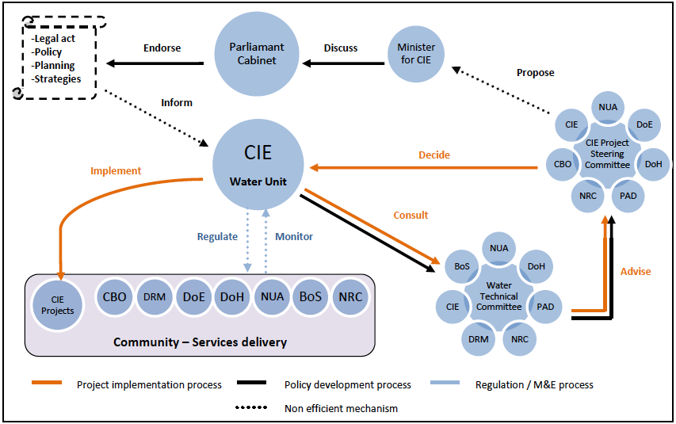

Figure 4: Decision making process for the water sector

Legal basis

Legal basis is mainly lacking to regulate, monitor and protect water supply sources. There is no legislation, strategy or guidelines overarching rainwater harvesting in Nauru. Groundwater resources are not under any legislation for exploitation although it is acknowledged that groundwater belongs to the above landowner. Therefore, there is no restriction or permit necessary for digging or extraction of water.

Parliament cabinet has endorsed the Water, Sanitation and Hygiene Policy, an important milestone for both IWRM and PACC project. Although it is likely to take time for the policy to be fully implemented (i.e. creation of related laws and programs), this is a great indication that the water sector is moving forward.

### Summary of key issues faced by the sector and emerging threats

Key issues and emerging threats faced by the water sector has been summarized in the National outlook for Water, Sanitation and Hygiene, developed by CIE (2011). Similar issues have been detailed in the Water, Sanitation and Hygiene policy developed by White (2011). They are summarized as follows:

**Operation and Maintenance** has been identified as a major issue in past reports (i.e. ADB 2011, Falkland 2009) at both national level (NUA RO plant and storage asset) and HH level (i.e. Rainwater collection and groundwater infrastructures). One of the main factors that lead to degradation of infrastructure is the country’s financial crisis and currently **low GDP**. At household level, low incomes is also contributing to poor maintenance, however, the **lack of** **community participation** is said to also play an important role. Since the civil works agency, which used to provide free maintenance services to households, has shut down in 200X after the financial crisis, Household maintenance has nearly stop and there is a current belief that government should be in charge of it.

**Water quality** is a major issue in Nauru with some of the **higher rates of diarrhea** incidence in the Pacific (WHO 2008). Contamination occurs principally in the groundwater but also in rainwater harvesting systems that are poorly maintained. It is worth noting that the desalinated water delivered by NUA is now free of contamination, with chlorine disinfection at delivery.

**Climate variability and climate change:** Climate variability is a natural phenomenon inducing a major threat for Nauru: Drought periods. Drought is a recurring threat that creates serious stress on the sector, the main one being the availability of potable water.

Climate change will bring additional issues, such as **sea level rise** and more uncertainty on climate patterns and occurrence of induced threats such as **drought periods**.

**Water infrastructure and supply** is currently insufficient to guaranteed **water security**. Domestic rainwater infrastructures are not in an optimum state to meet the population needs but is currently sufficient (i.e. In most dwellings) to provide enough water during average or above rainfall, especially if the dwellings have access to a secondary source of water. However, during **extended drought**, the national desalination plant is barely sufficient to provide the population with minimum water requirement (Drought strategy).

**Institutional capacity** is low and there is a **lack of skilled workers** for the sector. There is currently **no legal basis** to regulate the sector.

## Conjunctive use of water in Nauru

### Conjunctive use of water, what is it?

In most countries, conjunctive use of water refers to the coordinated use of surface water and groundwater. According to the New Oxford American Dictionary (2011) conjunctive means ‘’combined’’ or ‘joined together’.

In Nauru, there is no surface water and conjunctive use of water refers to the use of various sources, for different uses (i.e. Potable and non-potable), at different times. For example, picture an average household with access to groundwater and rainwater. It conjunctive use of water could be as detailed in table 3:

Table 3: Conjunctive water uses for an average household having access to groundwater in Nauru

|  |  |  |  |
| --- | --- | --- | --- |
| **Water sources** | **Above average rainfall** | **Low rainfall** | **Extended Drought** |
| **Rainwater** | * All uses | * Drinking only | * Not used   (Storage empty) |
| **Sea-water (Desalinated)** | * Not used (no need) | * Drinking only | * Drinking only |
| **Groundwater** | * Outdoor * Laundry | * Outdoor * Laundry * Personal bathing | * Outdoor * Laundry * Personal bathing * Cooking |

Note: The use of groundwater is not recommended for personal bathing, laundry and cooking due to the high contamination from fecal bacteria. However, this table reflects the findings detailed by Bouchet and Sinclair (2010).

### Conjunctive water use in Nauru

Historically, Nauruans have most likely been using a combination of rainwater and groundwater for hundreds of years. Rainwater was originally harvested using palm trees as a screen and wood storage (Picture 2). Elders recall times while during drought, people use to fetch water from natural galleries accessing groundwater.

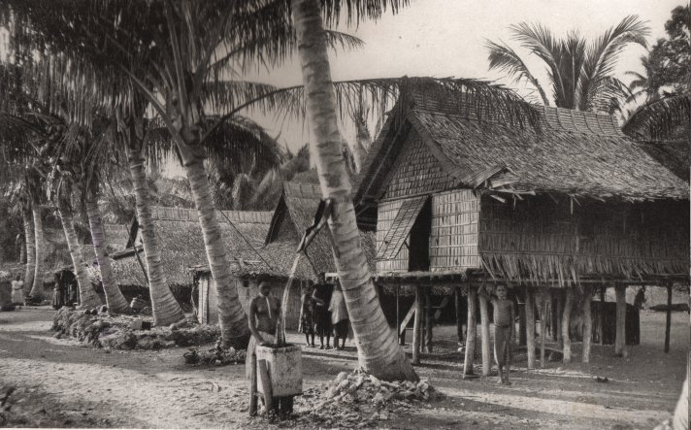

Picture 2: Rainwater harvesting in the old days

It is evident that Nauruan needs for water are far greater nowadays to sustain both lifestyle and public health and to support the island economic development.

During the past century, Nauru has been using a creative combination of water supply sources in order to support its economic development: Bulk water shipped by boat during the era of the Nauru Phosphate Corporation (NPC), Seawater reticulation system for toilet flushing (ex-NPC housing area), Multi Effect Distillation (MED) plant (Seawater desalination technology), extensive rainwater harvesting (ex-NPC housing area), and extensive groundwater abstraction (domestic well). Nowadays, the MED is not able to function anymore and it has been replaced by 3 small self-contain RO unit, producing a third of the MED total production, conducting household to rely more on Rainwater harvesting for their potable uses.

New technologies such as Reverse Osmosis (i.e. desalination) are efficient to produce high quantity of potable water. However it’s current high cost of production and maintenance makes it prohibitive as sole water supply source for Nauru. Identically, relying exclusively on rainwater is prohibitively expensive due to the large amount of storage needed to sustain supply during drought periods. Groundwater, due to the high variability of its quality, is not a reliable source of potable water. However, it is proven to be an indispensable source of non-potable water and potential source of potable water (i.e. in some areas).

Using rainwater, seawater and groundwater as conjunctive sources for water supply is a sensible way to sustainably improve Nauru’s water supply, leaving desalination technology for big users (i.e. hotels and industry) and to serve as a back-up supply for domestic supply during drought periods.

Currently, less than half of the population in Nauru is said to have access to a secondary source of water for non-potable use.

|  |
| --- |
| Part II: PACC demonstration projects |

## Introduction

Climate change is likely to increase the stress on availability of freshwater in Nauru. The PACC demonstration project scope is to enhance community resilience to drought, through suitable adaptation measures***.*** In order to do so, the PACC team has been working closely with the targeted communities and established that developing conjunctive water supply systems would be the most appropriate adaptation measures for the identified areas. A vulnerability and adaptation assessment (V&A) has also been undertaken for the selected sites to evaluate the current and future threat on the community in relation to drought events and review the available technical solutions. Two demonstrations projects have been proposed by the PACC project, as follows:

* **Demonstration Project 1:** Solar water purifiers in selected Households, Aiwo district.
* **Demonstration project 2:** Seawater reticulation system in Location**.**

This chapter presents both projects and details background research, selection process, expected benefits and M&E.

## Selected sites

### Sites location

Two districts has been selected to benefit from the PACC demonstration projects (Picture 3):

* **Demo project 1**: Selected Households in Aiwo district
* **Demo project 2:** Location area (i.e. of Denigomodu district)

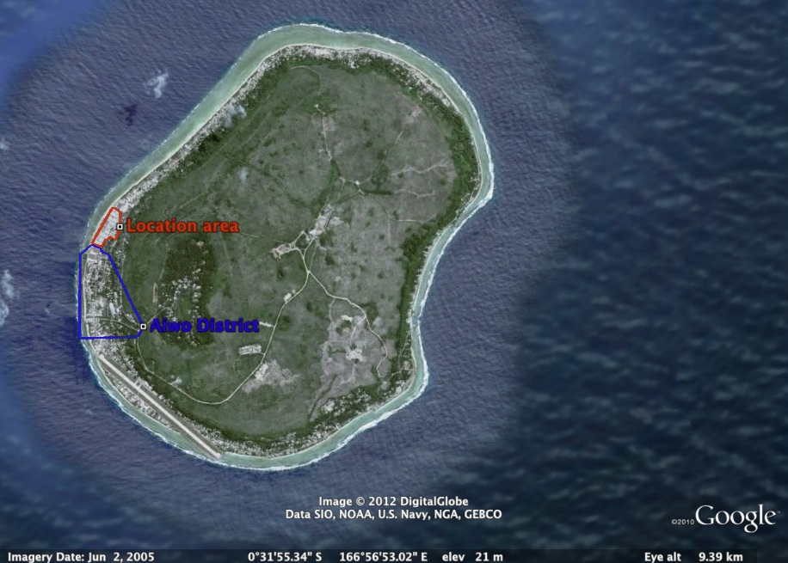

Picture 3: Aerial view of Location area and Aiwo district

### Selection criteria

Recognizing drought as the most threatening impact of climate change for Nauru, the PACC demonstration project has assessed two main criteria at national level to select the demonstration project areas:

1. **Heavy reliance on desalinated water:** Considering that most households in Nauru rely primarily on rainwater for potable water, areas with heavy reliance on desalinated water reflect a poor coping capacity against drought events (e.g. not sufficient storage per capita, no access to secondary source of water). According to NUC (2011), Location and Aiwo are the first two consumers of desalinated seawater. Reducing this two districts reliance on desalinated water will also increase availability of water for the entire island (i.e. releasing stress on the desalination plant).
2. **High density of Population:** Highly populated areas logically use more water than others and, in Nauru, are generally more vulnerable to drought event. Also, demonstrating the benefit of adapted measures to improve resilience to drought in these districts is likely to have a greater impact on water consumption at national level. Location area has got the highest density of population and Aiwo is one the highest populated district.

## Vulnerability and adaptation assessment

### Objectives and methodology

#### 3.1.1. Objectives

During the early stages of the project in August 2010, a V&A has been undertaken to assess the vulnerability of the selected sites toward environmental changes and evaluate available adaptation measures.

Aim of the V&A was to capture specific information from selected sites in relation to the main climate related threat (i.e. Drought) such as socio-economic features as well as future risks that could increase the community’s vulnerability; and also review the current coping capacity. After analysis of the collected data (Diagnostic), the V&A aimed to review and select the most suitable adaption measures for the selected sites (Prognostic).

#### 3.1.2. Methodology and process

The V&A used for this project is a 5-step process empowering various methodologies and tools for appraisal pilot areas such as literature review, community workshops, technical group working session and independent assessments (Table 4). A door-to-door survey in the selected districts, The Nauru Housing Water Project (NHWP), has been especially undertaken for the purpose of the V&A.

Table 4: data review and collection

|  |  |
| --- | --- |
| **Existing data** | **Collected data** |
| * PSCCP climate change report for Nauru * NAPA * PACC reports * Water, sanitation and Climate outlook * Water policy * IWRM diagnostic report * GW vulnerability report * ARMS rainfall data * Census 2006 data | * Nauru Housing Water Project * Community workshops * Meetings with community leaders * Technical working group sessions |

The vulnerability and adaptation assessment followed the above process:

1. Identification of current and future natural hazards likely to generate environmental changes affecting the water sector - *Environmental sphere;*
2. Identification of risks associated with environmental changes to the water sector - *Environmental and Socio-economic sphere;*
3. Identification of current and future capacity to cope with environmental change - *Socio-economic and Governance sphere;*
4. Prioritization of risks at community level;
5. General recommendations and review of adaptation measures for the two pilot sites.

Seven indicators are used through the document to facilitate the V&A process. Each indicator is linked to one or a couple of parameters used to identify particular risks associated to environmental change and adaptation capacity (table 5).

Table 5: Vulnerability indicators

|  |  |  |  |
| --- | --- | --- | --- |
| **Sphere** | | **Parameter** | **Vulnerability indicator** |
| **Environmental** | Climate | * Rainfall * Sea level | **VI-1. Water availability and quality** |
| Ecosystems | * Water dependency * Land uses |
| Hydrology | * Storage * Quality |
| Hydrogeology | * Yield * Recharge |
| **Socio-economical** | Demography | * Population size and distribution * Water demand | **VI-2. Water demand and population density**  **VI-3. Access to water**  **VI-4. Water use and**  **Usages**  **VI-5: Storage and supply infrastructure**  **VI-6: Income and GDP** |
| Infrastructure | * Water production and supply capacity * Water storage * Water asset |
| Economy and livelihood | * Water pricing * Cost of production * GDP * HH Income |
| **Governance** | Legislation | * Policies * Acts * Regulation * Guidelines | **VI-7: Sector reform and adaptive capacity** |
| Institutional | * Adherence to IWRM principles * Human resource capacity |
| Knowledge | * Literature/data |

Adapted from CSIR 2003

Community consultations have been central in the elaboration of the V&A. Community workshops have been held in both the location area and Aiwo district. The first set of workshops were initiated in early 2010 to inform the community of the PACC project and prioritize issues related to environmental change in the community. Once the vulnerability assessment completed, communities has been consulted again to present and discuss the feasibility of various adaptation measures and their efficiency in addressing community’s issues.

Finally, adaptation measures recommended in the V&A has been presented and adopted by the Aiwo and Location communities. This decision was forwarded to SPREP and submitted to the Parliament Cabinet of the Republic of Nauru.

### Vulnerability assessment: Key findings

As reviewed previously, the most threatening impact of climate variability in Nauru is on the deficiency of rainfall and resulting drought periods. In the selected districts for the demonstration project, adaptive capacity is generally low and some socio-economic factors are adding to the community’s vulnerability to drought (table 6).

Generally, the average density per dwelling is high in both districts (11). The majority of the population is young, and the population in both districts is expected to double by 2034. With no indication that the economy will develop on the island and offers more or better employment opportunity, this is a serious risk on the community’s capacity to develop and/or maintain household infrastructure.

In Aiwo, the current coping capacity against drought events is insufficient: Storage of rainwater per capita is often under a month capacity and the reliance on desalinated water is high. Some households in lower Aiwo are facing other issues: Groundwater oil (petroleum) pollution and industrial pollution (phosphate dust), disabling them from using these sources. Sea level rise could increase this threat, in increasing the risk of groundwater contamination from surface activities.

In Location, the current coping capacity is very low. Storage of rainwater per capita is up to a couple of weeks and the reliance on desalinated water is the highest on the island. Heavy reliance on desalinated water is also due to non-access to any secondary source of water. With the lowest average income on the island, Location is also the only place were a significant proportion of the inhabitants are not landowners, lowering their chances to develop household coping capacity.

Table 6: V&A key findings

|  |  |  |  |
| --- | --- | --- | --- |
| **Vulnerability indicator** | **Location** | **Aiwo** | **Parameter** |
| **VI-1. Availability and quality of water resources** | **Moderate** | **Moderate to High** |  |
| * Rainwater (frequent drought) * Groundwater (No access) * Seawater (Coastal access) | * Rainwater (frequent drought) * Groundwater * Seawater (Coastal access) | Water availability |
| * No data on groundwater quality in location. Likely to be brackish * Sea level rise is likely to increase the risk of groundwater contamination | * Rainwater in Lower Aiwo is often carrying dust from roofs * Pollution from oil (petroleum) can be find in several Well in lower Aiwo * High rate of contamination from fecal bacteria * Sea level rise is likely to increase the risk of groundwater contamination | Water quality |
| **VI-2 Storage and supply infrastructure** | **High** | **Moderate** |  |
| * 3 freshwater tank (6000L), only 2 in use | * 3 freshwater tank (6000L), 1 leaking * 1 groundwater tank with solar powered pump | Public asset |
| * Storage tanks- avg. 5000L (95% of HH) * Rainwater harvesting facilities (98% of HH) | * Storage tanks- avg. 5000 to 9000L (90% of HH) * Rainwater harvesting facilities (80% of HH) * Groundwater wells (25% of HH) | Private asset |
| **VI-3. Access to water** | **High** | **High** |  |
| Desalinated water (70%) | Rainwater (50%) and Desalinated water (50%) | Primary source of freshwater |
| Rainwater (30%) | Rainwater (50%) and Desalinated water (50%) | Secondary source of freshwater |
| 0% of the population access to groundwater | 25 % of the population access to groundwater | Access to a secondary source of water (non potable) |
| 30.5% of Household reports to often lack water | 37.6% of Household reports to often lack water | Water scarcity |
| **VI-2. Density of population and water demand** | **High** | **Moderate to High** |  |
| 5710 popn/km2 | * 1196 popn/km2 (100% of land area) * 3988 popn/km2 (30% of land area) | Population density |
| 3,85% | 2,09% | Growth rate (2006-2011) |
| * Per HH: 6 * Per dwelling: 11 | * Per HH: 6 * Per dwelling: 11 | Average population |
| * Per Capita: 170L * Per HH:1000L | * Per Capita: 170L * Per HH:1000L | Average water demand |
| 214,000L | 218,000L | Total daily water demand |
| **VI-5. Water uses and usages** | **High** | **Moderate to High** |  |
| 100% urban (100% domestic) | 100% urban (Breakdown) | Water use |
| 90% | 90% | HH using Flush toilet |
| * Average: 169L * During drought: 156L | * Average: 130L * During drought: 91L | Daily freshwater use per capita |
| * Average: Negligible * During drought: Negligible | * Average: 65L * During drought: 104L | Daily groundwater use per capita |
| **VI-6. Income** | **Moderate to high** | **Moderate** |  |
| 27% | 5% | Average income per HH $3,200< |
| 32% | 52% | Average income per HH >$7,800 |
| **VI-7. Sector reform and adaptive capacity** | **Moderate to high** | |  |
| In progress | | Sector reform |
| Low | | Current Adaptive capacity |

### Selection of adaptation measures

It is acknowledged from the vulnerability assessment that Aiwo and Location are facing similar threat from climate vulnerability and climate change. However, main differences in the physical and socio-economic environment and coping capacity have instigated the need to design two independent demonstration projects. The following section presents a review of the proposed adaptation measures and selection process.

#### Selection of adaptation measures for Location

Location area is the most populated area on the island and also gathers one of the lowest incomes per dwelling. Access to rainwater is scarce as people live in flats of really bad condition, with little rainwater catchment area per capita and aging concrete tanks. Because there is no access to any form of secondary source of water, freshwater account for all water uses. Therefore, there is a clear need to develop conjunctive water supply systems in Location. Providing households with a secondary source of water could dramatically reduce the use of freshwater, which mostly originates from the desalination plant, because of non-sufficient rainwater storage.

After discussion with the technical working group and the location community, selected options were:

* **Reticulated groundwater wells:** To drill a few wells around location area with the possibility of a reticulation system to all the flats in location.
* **Community groundwater tanks with solar pump:** To drill one or two wells around location area fitted with a 6000L storage tank and a solar powered pump.
* **Seawater reticulation system:** To rehabilitate the old seawater reticulation system in order to provide water for flushing toilet in all the flats.
* **Restoration of existing storage tanks in location:** To rehabilitate underground bulk storage in location in order to significantly increase the storage capacity for freshwater.

In order to assess the feasibility, relevance and sustainability of each option, a Multi Criteria Analysis (MCA) has been undertaken by the PACC team, using the recommendations from the vulnerability assessment (Table 7). For more detail on the attribution of scores, please refer to the V&A original document.

Table 7: Multi criteria analysis for selected adaptation options in Location

|  |  |  |  |  |  |
| --- | --- | --- | --- | --- | --- |
|  | **Parameter** | **O1: Reticulated**  **Groundwater wells** | **O2: Community groundwater tank (Solar pump)** | **O3: Sea water reticulation system** | **O4: Restoration of existing storage tanks in location** |
| **Environmental** | | | | | |
| **VI-1** | Water source available during drought | **3** | **3** | **3** | **2** |
| Potential Environmental impact | **1** | **1** | **2** | **3** |
| **Socio-economic** | | | | | |
| **VI-2** | Amount of water provided per capita | **3** | **3** | **3** | **2** |
| **VI-3** | Improve access to freshwater during drought | **0** | **0** | **0** | **2** |
| Improve access to a secondary source of water | **3** | **2** | **3** | **0** |
| **VI-4** | Contribution to daily water usage (%) | **2** | **2** | **1** | **3** |
| Health risk related to use | **1** | **1** | **3** | **2** |
| **VI-5** | Maintenance required | **1** | **2** | **0** | **3** |
| Expected lifespan | **2** | **1** | **2** | **3** |
| **VI-6** | Reasonable Running cost | **2** | **3** | **1** | **0** |
| Implementation cost | **1** | **3** | **1** | **2** |
| Economic benefit to the water sector | **3** | **2** | **3** | **0** |
| Landowners acceptance | | **0** | **0** | **2** | **0** |
| **TOTAL** | | **22** | **23** | **24** | **22** |

Issues such as availability to supply water during drought, health risks, required maintenance and landownership have been considered critical. After a review of the MCA, The technical working group and the community have selected the rehabilitation of the seawater reticulation system as the most suitable option.

As the rehabilitation process could be significantly expensive, a feasibility study and cost benefit analysis have been highly recommended. Without more details on the implementation, running and maintenance costs for the seawater reticulation system no final decision can be made. If further investigations reveal that the project is not feasible or that the government does not have the capacity to run or maintain it, other solutions mentioned above will need to be reconsidered.

#### Selection of adaptation measure for Aiwo

Aiwo present similar characteristics in housing and water supply as the rest of the island. However, some dwellings in Aiwo are facing issues with their water supply:

* Contamination of the groundwater with oil (i.e. petroleum) from industrial pollution;
* Dust deposit in roofs and water tank from phosphate industry.

Even if the dust deposit only seems to be a taste issue (no health concerns have been identified so far), it has led to some households to completely abandon rainwater harvesting, thus relying extensively on the desalinated water. Regarding the oil contamination, efforts are still yet to be made to stop the source of pollution. In Aiwo, the community has expressed its interest in a system that will enable households facing the above issues to use their rainwater or groundwater.

After discussion with the technical working group and Aiwo community, selected options were:

* **Reticulated groundwater wells for upper Aiwo:** To drill a few well in Upper Aiwo with the possibility of a reticulation system to selected Households.
* **Reticulated groundwater wells for lower Aiwo:** To drill a few well in Lower Aiwo with the possibility of a reticulation system to selected Households.
* **Improvement in rainwater harvesting system (Roofing and gutter):** To revamp roofs (e.g. remove asbestos) and repair/install guttering system for selected Households.
* **Improvement in rainwater harvesting system (Filters):** To install filters on rainwater tank in selected households to avoid dust from phosphate industry to enter tanks.
* **Solar purifier for selected Households:** To connect solar purifier onto groundwater in selected Household in order to convert small volume of brackish-contaminated water into drinking water.

In order to assess the feasibility, relevance and sustainability of each option, a Multi Criteria Analysis (MCA) has been undertaken by the PACC team, using the recommendations from the vulnerability assessment (Table 8). For more detail on the attribution of scores, please refer to the V&A original document.

Table 8: Multi criteria analysis for selected adaptation options in Aiwo

|  |  |  |  |  |  |  |
| --- | --- | --- | --- | --- | --- | --- |
|  | **Parameter** | **Reticulated groundwater wells for upper Aiwo** | **Reticulated groundwater wells for lower Aiwo** | **Improvement in rainwater harvesting system for selected HH (Roofing and gutter)** | **Improvement in rainwater harvesting system for selected HH (Filters)** | **Solar purifier for selected HH** |
| **Environmental** | | | | | | |
| **VI-1** | Water source available during drought | **3** | **3** | **0** | **0** | **3** |
| Potential Environmental impact | **1** | **1** | **3** | **3** | **2** |
| **Socio-economic** | | | | | | |
| **VI-2** | Amount of water provided per capita | **3** | **3** | **2** | **2** | **1** |
| **VI-3** | Improve access to freshwater during drought | **0** | **0** | **0** | **0** | **3** |
| Improve access to a secondary source of water | **3** | **3** | **0** | **0** | **2** |
| **VI-4** | Contribution to daily water usage (%) | **2** | **2** | **3** | **3** | **3** |
| Health risk related to use | **1** | **0** | **2** | **2** | **3** |
| **VI-5** | Maintenance required | **1** | **1** | **3** | **2** | **3** |
| Expected lifespan | **2** | **2** | **2** | **1** | **1** |
| **VI-6** | Reasonable Running cost | **3** | **3** | **3** | **3** | **3** |
| Economic benefit to the water sector | **3** | **3** | **2** | **2** | **1** |
| Landowners acceptance | | **2** | **2** | **3** | **3** | **3** |
| **TOTAL** | | **24** | **23** | **23** | **22** | **28** |

Issues such as availability to supply water during drought, health risks, required maintenance and landownership have been considered critical. After review of the MCA, The technical working group and the community have selected the solar purifier system as the most suitable option.

Main advantages identified for the solar purifier are:

* It enables both groundwater and rainwater to be purified to international drinking quality standards.
* It enables groundwater to be used all year to supplement rainwater harvesting and as an emergency potable water source during drought.
* It is an affordable solution for households in Nauru.

## Demonstration projects overview

### Project 1: Solar Purifiers for selected Households in Aiwo district

#### Project summary

The solar purifier main purpose is to give access to a minimum amount of potable water per day during drought to Households that cannot use their groundwater for most of uses, primarily because of oil contamination and also due to a high salinity. With the project, each household is receiving 80L of additional potable water per day. During drought, this is a considerable amount of water that is aiming to be used firstly for drinking, cooking and if in sufficient quantity, personal bathing. During average to high rainfall, this is an additional potable water supply. Also, while mostly safe, stored rainwater cannot be guaranteed free of contamination (i.e. If no disinfection process is in place). The process involved within the purifier guarantees potable water free of contamination. (Table 9).

Table 9: Demo Project1: Solar purifier in Aiwo - Project summary table

|  |  |  |
| --- | --- | --- |
| **Project Status** | | |
| * Demo project 1 is currently in monitoring phase. * The solar panels have all been installed during 2nd /3rd quarters 2011. | | |
| **Beneficiaries** | | |
| Number of Household benefiting from the project | | 19 |
| Number of community tank benefiting from the project | | 1 |
| Number of panel installed per HH or community tank | | 4 |
| **System features** | | |
| Water quality | Potable (WHO drinking standards) | |
| Water uses | Drinking/ all uses | |
| Effective water production rate per HH[1] | 80L per day (4 panels) | |
| Total water supplied per year by demo project 1 | 584,000L | |
| **Estimated costs** | | |
| Implementation costs | **$AUD 78,934.00** | |
| Estimated annual cost of production per HH | (Pumping Costs for HH) | |
| Estimated annual total cost of production per year to NUC | (Pumping cost to NUC) | |

#### System component and design

Solar water purifiers are solar panels covering a water circulation circuit creating a distillation process. Distillation involves boiling water to produce steam that is then condensing on a cooler surface and became distilled water. A single panel produces around 20L of water per day and can be installed on a roof, a platform or concrete top. The purified water can be diverted to a rainwater tank or other storage (Picture 4).

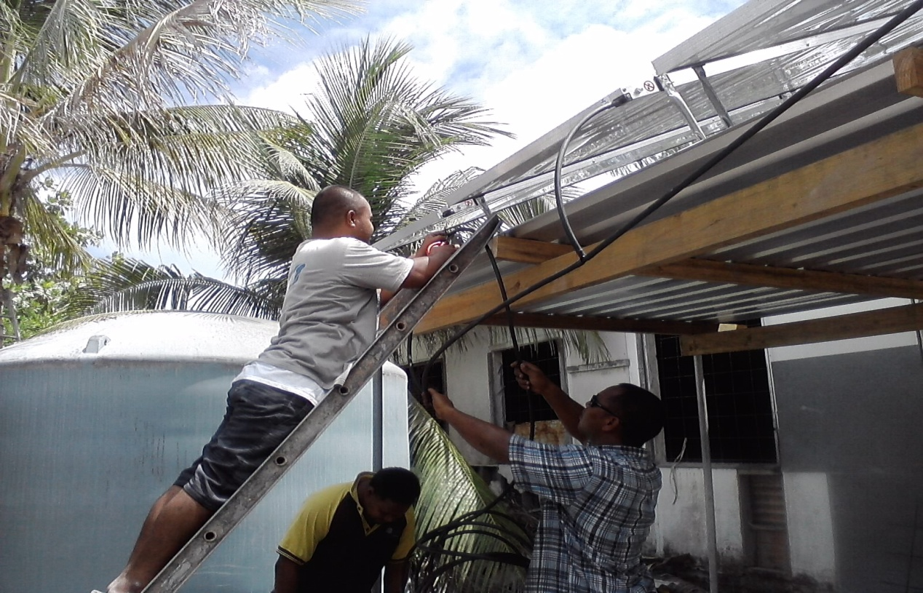

Picture 4: Connection of 4 solar panels on top of a platform designed for householders in Aiwo district.

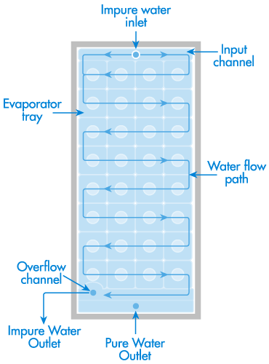

**The technology:** The technology used for this project is the Carocelltm Solar Desalination designed by FCubed. Similar technology can be found with other global provider such as Sunsure water.

**The process (distillation):** The system receives impure water (i.e. groundwater) through pump and disperses it evenly. Solar energy heats the water; it vaporizes and then condenses on the inside of the composite plastic panel enclosure. Droplets of distilled water run down into a pure water outlet at the bottom of the unit. Distilled water is free of dissolved materials such as salts and heavy metals, suspended sediment or bacteria and viruses that remain in the un-vaporized liquid (Figure 5).

Figure 5: Solar water purifier process (Sunsure Water 2012)

**Water quality:** The water produced after the distillation process is potable and meets the WHO drinking water standards.

#### Operation and maintenance

Solar purifiers are installed at a household level with currently 4 panels per household. The system is operated by the household and doesn’t require any intensive maintenance. The lifespan of the solar purifier is 15 years and no replacement of material is expected during this time.

The maintenance is very low because there is no complex filter system or chemical involved (i.e. to be replaced), no electronic (i.e. can failed) or moving part (i.e. can break). According to the manufacturer, the only maintenance required is a regular cleaning of the panels to ensure their best efficiency (Fcubed 2012).

#### Expected impact at the community level

The solar purifier is an affordable technology for the average Household in Aiwo, and for a majority of households in Nauru. Some householders were initially reluctant to directly divert the water produced by the purifier into their main drinking water tank, because they do not necessarily trust the technology. With the monitoring program in place, the PACC team should be able to demonstrate that the water produced with the solar panel is even safer than the harvested rainwater.

Assuming that the water quality is complying with WHO standards regulations and that the panel are resisting to the local environment, the panels could be marketed in local business and proposed to Household as an affordable solution to improve reliance to drought events.

### Project 2: Seawater reticulation system for toilet flushing in *Location*

The information provided below is based on the draft feasibility study developed by Aremwa (2012). There are still some few gaps of knowledge, especially regarding maintenance cost and extent of the project. Opportunities for co-financing, extending the project to Denig district are currently being discussed. Please contact the PACC project coordinator (contact detail page 2) for up to date information on the project.

#### Project summary

The seawater reticulation system aims at providing an alternate source of water for non-potable use in location area, thus saving precious potable water. This is a rehabilitation project of the once operational and effective seawater reticulation system built by the BPC to supply water for the following uses:

* Industrial – Engine cooling of Power Station generators & refrigeration condenser cooling;
* Domestic – Toilet flushing, swimming pools;
* Emergency – Fire fighting

The intended use for its rehabilitation is toilet flushing only. However, it’s noticeable that it could also provide for other uses if necessary (Table 10).

Table 10: Demo Project 2: Seawater reticulation system - Project summary

|  |  |  |
| --- | --- | --- |
| **Project Status** | | |
| Demo project 2 is in design phase.  The draft feasibility report has been release in early 2012. | | |
| **Beneficiaries** | | |
| Number of People benefiting from the project (estimates) | | Up to 2,600 |
| Number of Household benefiting from the project | | 506 |
| Number of government building and commercial business benefiting from the project | | Up to 14 |
| **System features** | | |
| Water quality | Untreated seawater | |
| Water uses | Flushing toilet, industrial, fire fighting. | |
| Water production capacity | Up t0 200,000L per hour | |
| Total water supplied per year by demo project 2 | 18,250,000 L (low estimate) | |
| Water distributed per day per HH | Unlimited | |
| **Estimated costs** | | |
| Implementation costs (Estimate range) | | $300,000 to $500,000 |
| Estimated annual running cost with subsidies | | $1,000 |
| Estimated annual running cost without subsidies | | $3,000[2] |

#### System component and design

The seawater reticulation system is a network system that will supply seawater directly into connected households.

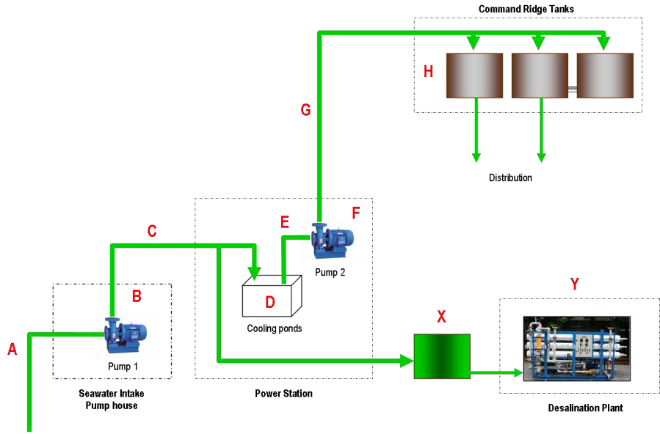**System description:** Seawater is initially pumped from the intake pump house (B) to a set of underground concrete tanks (D) also known as the cooling ponds. These tanks are situated at the Power Station (Figure 6).

Figure 6: Seawater reticulation network

Seawater is further pumped from the cooling ponds up to the Command Ridge concrete storage tanks (H). Situated on the highest point of Nauru (70 meters), this seawater is gravity-fed through a pipeline distribution network.

This seawater source currently supplies water to three RO units situated also at the Power Station.

**Extent of the network:** The first intention of the adaptation measure was to focus on location district only. However, there is an opportunity to extend the network that use to cover a broader area than just location (Figure 7). The red dashed line on Picture x represent the location area only. The black line represents the possible extent of the network.

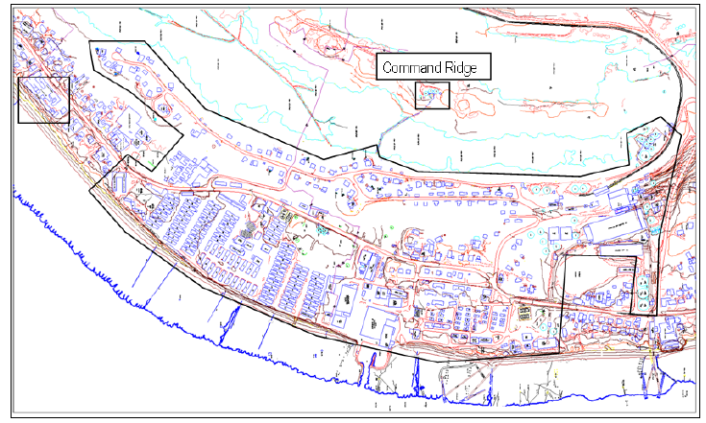

Figure 7: Seawater reticulation system, network-covered area

If the system is extended to Denig and part of Aiwo district, the total population serves by the network will be up to 2,600, which represent 25% of the entire island population (Table 11).

Table 11: Breakdown of population deserved by the network

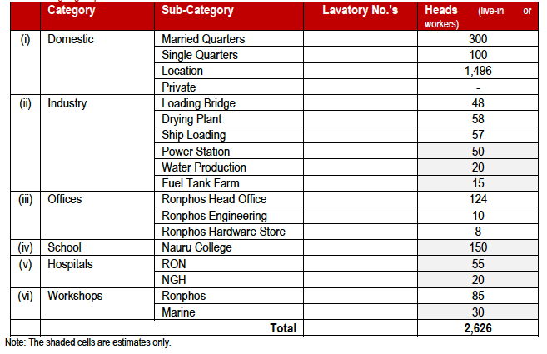

**Expected freshwater saving:** According to Aremwa (2012), and based on an estimated use of 25 liters per person per day for flushing toilet, the seawater reticulation system could supply up to 70,000 liters of water per day. It is not clear yet how many additional households and buildings (i.e. excluding location) are currently using freshwater for toilet flushing. Considering an estimated 2000 people using freshwater for toilet flushing, the freshwater (desalinated water) savings per day will be around 50,000L (Table 12)

Table 12: Seawater consumption function of population

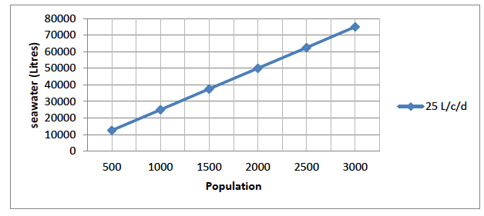

#### Operation and maintenance

The reticulation system will be added to the national water infrastructure and operated under NUC budget. Running costs have been evaluated from $1000 to $3000 per year (i.e. depending if the current subsidies on petrol provided by the Australian Government are taken into account or not). Regular maintenance will be needed for the system’s main components: Pumps, pipes, tanks and home connection’s network. There are yet no estimations on the annual maintenance cost, but it is fairly secure to say that NUC will have the capacity to maintain it as:

* The system doesn’t require expensive parts and hardware to be changed regularly;
* Maintenance capacity (knowledge) and hardware parts can be find locally.

#### Expected impact on national water supply

According to Aremwa (2012), the government could save an estimated $70,000 per year by using seawater instead of producing desalinated water for toilet flushing. This estimation is based on the implementation of a new RO plant, considering a water production cost estimated at $4 per KL. So if we compare the cost of supplying sea water for flushing toilet against the cost of supplying desalinated water from a new RO plant that will produce water at $4 per Kl, the saving will then be $70,000 per year.

However, according to the NISIP (2011), the current total cost of production for desalinated water is up to $20 per KL (i.e. mainly due to major losses in the system). Therefore, in the current situation, the seawater reticulation system could save NUC an estimated $400,000 per year.

It is important to note that both estimations are based on an assumed steady production of desalinated water. In reality, these saving figures are likely to be realistic during an average or above rainfall year. However, during a drought period, because the water demand is higher than the supply capacity, the production of water will not decrease. In this case, the implementation of the seawater reticulation network, by releasing an estimated 50,000L of desalinated water per day, will help to provide more freshwater to the entire island, which is its primary targeted objective.

## Expected outcomes

The main objective of the demonstration projects is to *implement successful adaptation measures in order to reduce the water sector’s vulnerability* (PACC project outcome 2). Expected outcomes are detailed in the flowchart bellow (Figure 8):

Figure 8: Project Outcomes flowchart

I**mplement successful adaptation measures**

Increase access to drinking standards water all year long

Give access to a minimum of potable water per day to HH during drought

Decrease water production cost during average rainfall year

Increase availability of freshwater during drought

**Demo project 2:** Supply seawater to households previously using freshwater for toilet flushing

**Demo project 1:** Purify groundwater to provide sufficient drinking water to HH during drought

Reduced demand for desalinated water in Nauru with opportunities to extend the network to other areas

19 HH benefiting from an affordable household solution available to provide drinking quality water all year long

Support future planning for the water sector

**Reduced vulnerability for the water sector**

Overall, the demonstration project is expected to deliver the following outcomes:

1. **Support future planning for the water sector:**

* Demonstrate effectiveness of conjunctive use of water at household level
* Demonstrate effectiveness of conjunctive use of water at community level

1. **Release pressure on the demand for desalinated water:**

* Release up to 5% of the total demand for potable water during drought periods (thus reducing the likelihood of water borne disease from contaminated water)
* Decrease the production of desalinated water during average and above rainfall. This could save up to $400,000 per year

1. **Provide 19+ Households with drinking water all year long.**

## Monitoring and Evaluation

The monitoring and evaluation (M&E) process is an ongoing activity (from day one of project implementation) and has been a vital part of the demonstration project. The M&E process is used to assess whether or not the project is reaching intended objectives and if not, what could be modify or improved in order to deliver expected outcomes.

### Indicators and monitoring process

M&E process commonly uses two different types of indicators: Quantitative and qualitative.

Quantitative indicators are often seen as objective and verifiable. They take into account hard facts, number or logical deduction. Quantitative indicators are great to assess outputs of projects.

Qualitative indicators on the other end are more subjective and hard to verify. They are based on people perceptions and actions. Qualitative indicators are however important, especially for project that aims at services delivery to the community, to assess weather or not the community is satisfied with the project and likely to take ownership of it.

The following table details quantitative and qualitative indicators that have been set so far for the PACC demonstration project. Other indicators could be added and some suppressed if they appear to be insufficient or irrelevant (Table 13).

Table 13: Monitoring indicators

|  |  |  |  |  |
| --- | --- | --- | --- | --- |
| **Demo project 1:** | | | | |
| **Indicator** | **Type** | **Output** | **Agency in charge of monitoring** | **Status (03/12)** |
| 1. E-coli level in water <0 (MPN/l) | Qt | * Water quality meets WHO standards | Water unit | Testing kit ordered |
| 1. Amount of water produced per Household per day (L) | Qt | * Availability to provide sufficient drinking water all year long * Domestic consumption impact | Water unit | Monitored |
| 1. Interest of the community in using the system | Ql | * Ownership * Sustainability | Water unit | Community Initiative  Continual Monitoring for Feedback |
| 1. General state of the system | Qt | * Quality of the product and strength against natural environment | Water unit | Monitoring |
| **Demo project 2 (proposed indicators)** | | | | |
| **Indicator** | **Type** | **Output/benefit assessed** | **Agency in charge of monitoring** | **Status (03/12)** |
| 1. Monthly power consumption (MWh) | Qt | * Energy efficiency of the system | NUC | Na |
| 1. Monthly water distributed (KL) | Qt | * Yearly input in national water supply * Domestic consumption impact | NUC | Na |
| 1. Number of people connected to the system | Qt | * Sustainability * Ownership | NUC | Na |
| 1. Percentage of running costs paid through user fee | Qt | * Cost recovery | NUC | Na |
| 5. Yearly maintenance cost | Qt | * Cost recovery * Sustainability | NUC | Na |
| 6. Impact on monthly availability of potable water for consumers | Ql | * Sustainability * Effectiveness of the project | Water unit | Na |

### Evaluation process

The evaluation process reviews results from indicators and assess if they are meeting expected benefit. Evaluation and review of each demo project is an ongoing process. Every 6 months, an evaluation report will document effectiveness of the project, using current indicators.

If the indicators reveal that the project is not meeting expected outcomes, the PACC team will take necessary action to identify and address the issues to ensure validity of the Monitoring and Evaluation Process. This will be then taken up with the Water Unit established under the Department of CIE.

|  |
| --- |
| Recommendations |

The following recommendations have been identified by the PACC project and drawn from experience and pitfall in project management in Nauru. Decision makers and project coordinator should consider these recommendations with care during design and implementation of water supply projects:

1. **Community specific:** Nauru is a relatively small island and the different community/districts on the island present a lot of similarities. However, while looking at a Household or community project it’s important to understand the specificity of the area for criteria such as average income, current status of water and sanitation, geography and geology, household locations and population density as well as history of projects and previous initiative for community level project in a selected area.
2. **Cost effective:** It is vital for the project sustainability to ensure that the recipient (government agency, SOE or Household) have sufficient capacity to run and maintain the infrastructure. For national and community project that involved significant running and maintenance cost, cost recovery mechanisms should be developed (e.g. such as introducing a user fee).
3. **Identify operator and maintenance needs:** Maintenance of infrastructures and water asset is a major issue in Nauru. The overall state of water storage and network is poor and there is yet no recovery mechanism for the desalinated water supply.

At a Household level 50% of domestic rainwater harvesting is not properly maintained.

It is thus capital to fully consider maintenance issues during a project design, including running costs, funding and operator capacity and interest in maintaining the related infrastructure.

1. **Consider health and environmental issues:** Health issues need to be considered with care while designing a conjunctive supply project, especially if the water supplied is of non-drinking quality. For example, if untreated groundwater is to be supplied to household for flushing toilet only, it is vital to ensure that occupants will not use the water for water other purpose (i.e. washing, cooking or even drinking) in order to protect them from contracting waterborne diseases.

Environmental issues are also vital to avoid further contamination of scarce water resources. For example, a community RO plant should be monitored to ensure that no saltwater or brine from desalination plant is spilled inland. Salt intrusion into the island porous soil could heavily pollute the groundwater. Other environmental issues such as sewage disposal or other waste attached to the use of the supplied water will also need to be fully integrated and managed as part of the project.

|  |
| --- |
| References |

Aremwa 2012, Restoration of the Nauru Command ridge seawater reticulation system, transfer pump & pipeline system, A technical& feasibility study, Pacific Adaptation to Climate Change project, The Republic of Nauru.

ADB 2010, Fact sheet, Asian Development Bank and Nauru, viewed online in 23rd of March 2012, http://www.adb.org/Documents/Fact_Sheets/NAU.pdf

BoS 2011, National Census Primary Result, Draft Excel file, Republic of Nauru.

Bouchet and Sinclair 2010, *Assessing Vulnerability of Shallow Groundwater Domestic Wells In Nauru.* Pacific Hydrological Cycle Monitoring System (HYCOS) and The Disaster Risk Reduction in Eight Pacific ACP States (B-Envelope) projects, SOPAC, Suva, Fiji Islands.

CIA 2009, Nauru Facts, The world Factbook, Center of intelligence Agency, USA, viewed online 14th March 2012, <https://www.cia.gov/library/publications/the-worldfactbook/geos/nr.html>.

CIE 2011, *Rainwater Harvesting data summary*, Geographical Information System, Republic of Nauru.

Falkland 2009, Country Implementation Plan for Improving Water Security in the Republic of Nauru, SOPAC Secretariat, Fiji.

Jacobson and Hill 1997, Geology and Hydrogeology of Nauru island, Geology and Hydrogeology of carbonate islands, developments in sedimentology 54, Hl Vacher and T Quinn, Elsevier Sciences BV.

NBS 2009, *Demographic and Health Survey 2007*, Secretariat of the Pacific Community, Noumea, New Caledonia.

NPC 1988, ENGR 59.MS1/1, Nauru Phosphate Company, Nauru, Draft only.

PACC 2009, Report of in-country consultation, Pacific Adaptation to Climate Change Nauru.

PCCSP 2011, Climate Change in the Pacific: Scientific Assessment and new research, volume 2: Country Report, Chapter 8: Nauru, pp. 129-140, Pacific Climate Change Science Program Partners, Australia.

PRISM 2010, Population and demography-2009 estimates, Pacific Regional Information System, Secretariat of the Pacific Community, Noumea, New Caledonia, viewed online 23rd March 2012, http://www.spc.int/prism/Social/Demog/popnstats09_estimates.html.

White 2011, *National Water, Sanitation and Hygiene Policy Framework for the Republic of Nauru*, Pacific Integrated Water Resources management (IWRM) National Planning Programme, SOPAC secretariat, Fiji.

1. Tested in 2 different demo site in Nauru
2. This doesn’t include implementation and maintenance costs